TRẦN NGUYỄN THƯƠNG TRƯỜNG - ITITIU19228

REPORT LAB5 CA

Question 5.1:

* 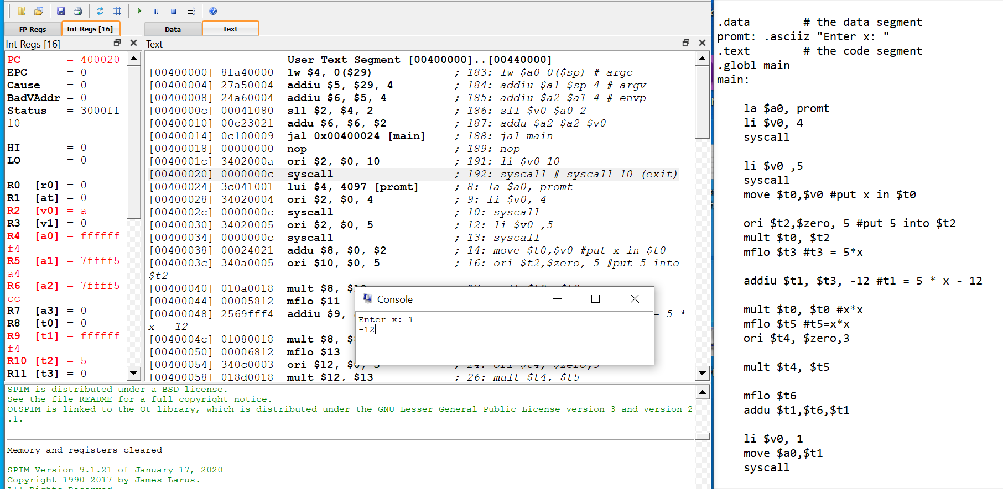

Question 5.2:

* 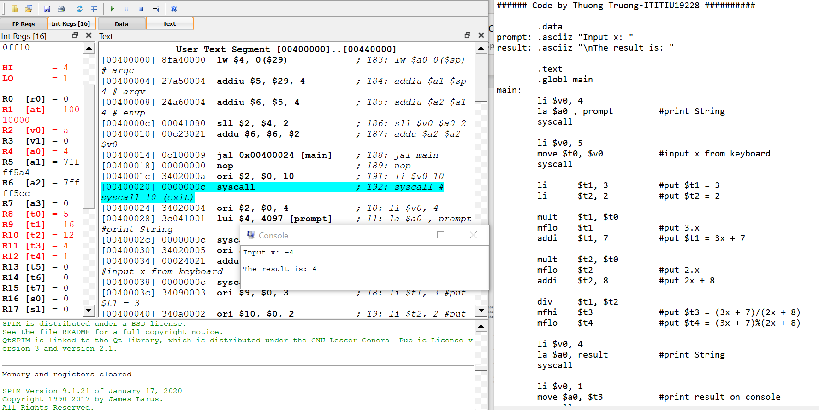

Question 5.3:

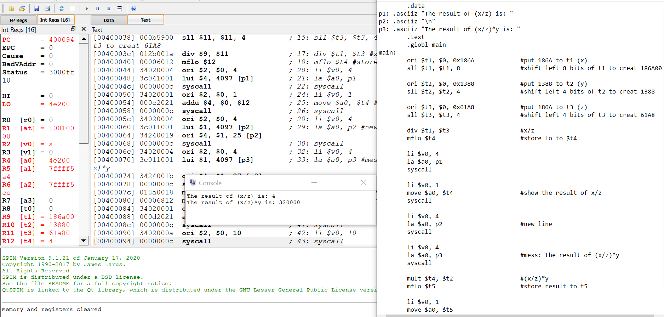

Question 5.4:

|  |  |  |  |  |
| --- | --- | --- | --- | --- |
| Operand 1 | 0x00001000 | 0x00000FFF | 0x0000FF00 | 0x00008000 |
| Significant Bits | 13 | 12 | 16 | 15 |
| Operand 2 | 0x00001000 | 0x00000FFF | 0x0000FFFF | 0x00001000 |
| Significant Bits | 13 | 12 | 16 | 13 |
| Product | 0x1000000 | 0x00FFE001 | 0xFEFF0100 | 0x08000000 |
| Significant Bits | 25 | 24 | 32 | 28 |

